**Software Design Specification**

**for**

TetrisBlast

Version 1.0

Prepared by

Group Name: .DUEL

|  |  |  |
| --- | --- | --- |
| Lim Pei Yong | 36732 | [mike.limpeiyong@gmail.com](mailto:mike.limpeiyong@gmail.com) |
| Abdul Rahim Bin Mohamad | 35282 | [chongpitt@gmail.com](mailto:chongpitt@gmail.com) |
| Lim Chong Fatt | 36712 | [shakion14@gmail.com](mailto:shakion14@gmail.com) |
| Hoe You Tien | 36249 | youtien3062@gmail.com |
| William Ngu Wee Hong | 39322 | wnwh6717@gmail.com |

|  |  |
| --- | --- |
| Instructor: | Mdm Nurfauza Jali |
| Course: | TMP 3413 Softtware Engineering Lab |
| Lab Section: | *Wednesday 9am – 11am* |
| Teaching Assistant: |  |
| Date: | 13 Nov 2014 |

Contents

Revisions ii

1 Introduction 1-2

1.1 Purpose 1

1.2 System Overview 1

1.3 Definitions, Acronyms and Abbreviations 2

1.4 Supporting Materials 2

1.5 Document Overview 2

2 Architecture 3-4

2.1 Overview 3

2.2 USER INTERFACE 4

2.3 FUNCTIONALITY 4

2.4 GAME CONTROL 4

3 High Level Design 5

3.1 View / Model Component 1..n 5

Appendix A – Group Log 6

Revisions

| Version | Primary Author(s) | Description of Version | Date Completed |
| --- | --- | --- | --- |
| Draft Type and Number | Full Name | Information about the revision. This table does not need to be filled in whenever a document is touched, only when the version is being upgraded. | 00/00/00 |

# Introduction

## Purpose

This Software Design Specification (SDS) is for the TetrisBlast. This SDS would break the project into several components. Then the purpose of each component will described in detail and also how it will be implemented. This SDS will also act as a tool to do the verification and validation of the final product.

## System Overview

Start a new game

Play hard mode

Learn how to play

View high scores

Play normal mode

Player

The diagram above is the use case diagram of SRS. That shows what players can do with game. A game must provide a user guide and TetrisBlast do provides it. Players can go to “learn how to play” to learn how to play the game. TetrisBlast also only supports single mode and it has two modes of playing, which are normal mode and hard mode. After the playing, players can view their score by go to “view high scores”.

## Definitions, Acronyms and Abbreviations

SDS = Software Design Specification

## Supporting Materials

NONE

## Document Overview

In section 1.0, it is about the introduction, game overview, terms and references, and the brief overview of the each section of the documents. In section 2.0, it is about the overview of game architecture and its components. In section 3.0, it is about the high level design of the game. It is also about the high level control view of the game.

# Architecture

This section provides the architecture design of the Tetris game. It includes the final version of the game Component Diagram which illustrates the different components, their interfaces and the dependencies between components. The main principles that led to the proposed design are:

* Maintainability
* Understandability
* Expected change

In Section 2.2, different components will be further discussed how they worked.

## Overview

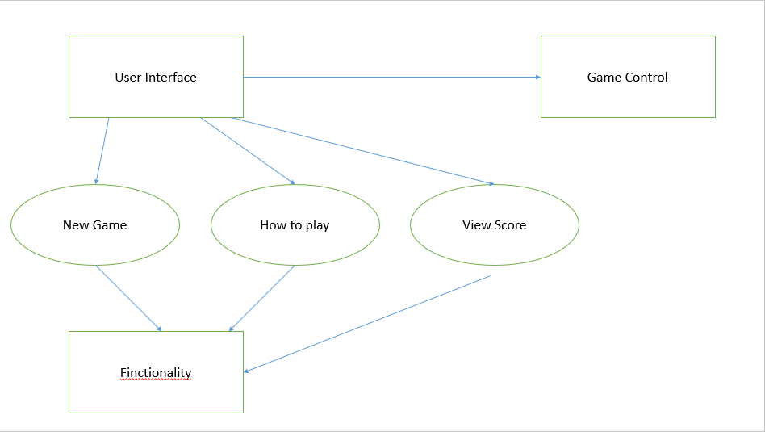

As shown in Figure 1 above, Tetris game consists of three main components:

1. User Interface
2. Game Control
3. Functionality

All three components in Figure 1 have cover certain functional areas and each component can be modified and changed without affecting other components. These three components were separated with clear and simple interfaces for each other so that the architecture more easy to understand and maintain.

## User Interface

Function of User Interface (UI) component is to provide player with graphical interface and guide player to understand the whole game effectively. UI depends on:

1. New Game interface
2. How To Play
3. View Score interface

All of these three interfaces are provided by the Functionality component. New Game interface enables player for the function to start a new game. How To Play interface guide player to play the game. View Score interface let player to view highest score in the game.

## Functionality

There are three functionalities provided by Tetris game to the player which are:

1. View the rule of the game
2. Play the game
3. Check the highest score of the game

Functionality component cover the area of game function and it is independent from other component of the game.

## Game Control

Game Control component covers the responsibilities of controlling the dropping of the blocks and recording the scores when player dissolved the blocks. This component controls the major part of the game which is depends on one interface. The interface depended by Game Control component is New Game interface that provided by Functionality component. Game Control uses this interface to control the game for player to play.

# High Level Design

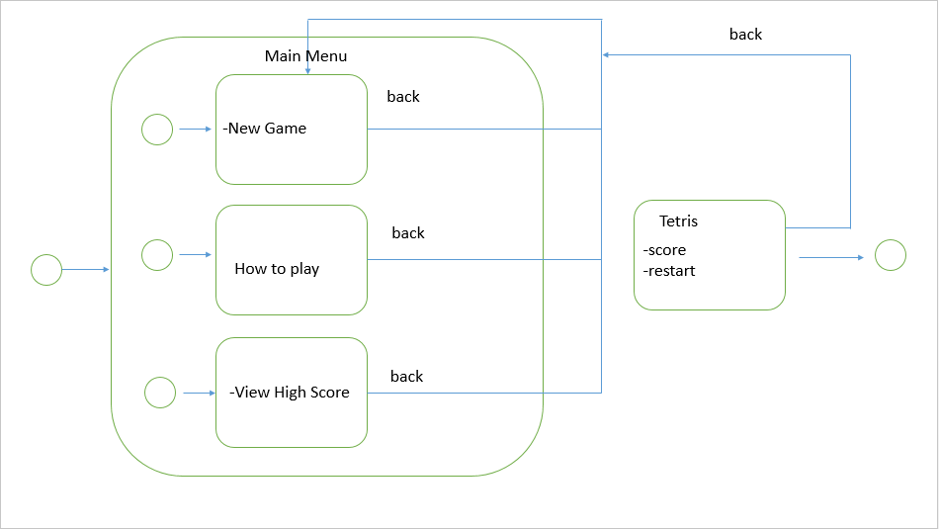

This section describes in further detail of the interactions between the Tetris game components and their corresponding interfaces. To illustrate the dynamic behaviour of the Tetris game, Control view using Statecharts has been used. Statecharts model the behaviour from the perspective of a single entity. The entity that is modelled in Figure 2 is the complete Tetris game.

The event is starting from the game being turned ON which is the first event. Second event will be started by providing player with Main Menu interface and then wait for player to choose the next step. There are three events inside Main Menu, they are New Game, How To Play and View High Score. Every time when player makes an option, the related event will be occurred.

When player select New Game, player will be led to a new interface which contains normal and hard gaming modes. Player can choose either one gaming mode to bring them to start the Tetris game. When Exit = False event is selected by player, player will back to the Main Menu.

From the gaming mode, after player choose the mode then player will be led to next interface which is Tetris game interface. Inside the Tetris game interface, there is a Back event and Restart event. Back event can lead player back to the gaming mode while Restart event can makes the Tetris game interface refreshed.

The How To Play event in Main Menu can lead player to another interface which will let player understand more about the game. Same concept is used when player selected the Exit = False event.

From the Main Menu, player can go through the View High Score event and the event will bring player to other interface that contains the highest score of the game. There is an Exit = False event inside the interface and it will leads player back to Main Menu interface.

Appendix A – Group Log

|  |  |  |  |  |
| --- | --- | --- | --- | --- |
| Minutes Meeting | Date | Duration | Venue | Members |
| 1 | 26th September 2014 | 3 hours | Student Interaction Rom | All members |
| 2 | 5th October 2014 | 3 hours | CAIS UNIMAS | All members |
| 3 | 16th October 2014 | 3 hours | CAIS UNIMAS | All members |
| 4 | 17th November 2014 | 4 hours | CAIS UNIMAS | All members |
| 5 | 3rd December 2014 | 4 hours | Student Interaction Rom | All members |